Exercise 7: Implementing Constructor and Setter Injection

Application Context
Configuring the constructor and setter
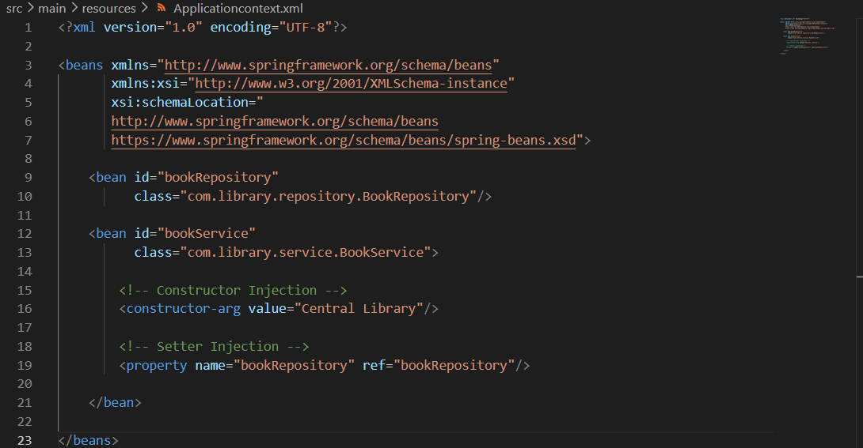

Book Service
Methods linked to the book repository
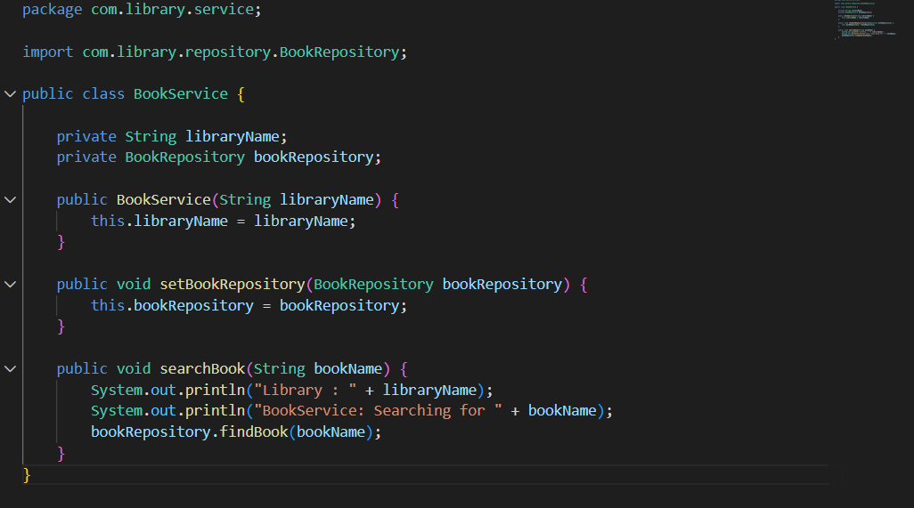

Book Repository
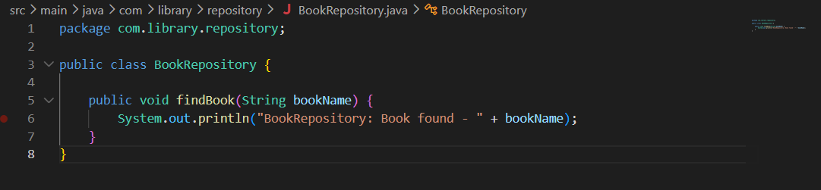

Main class
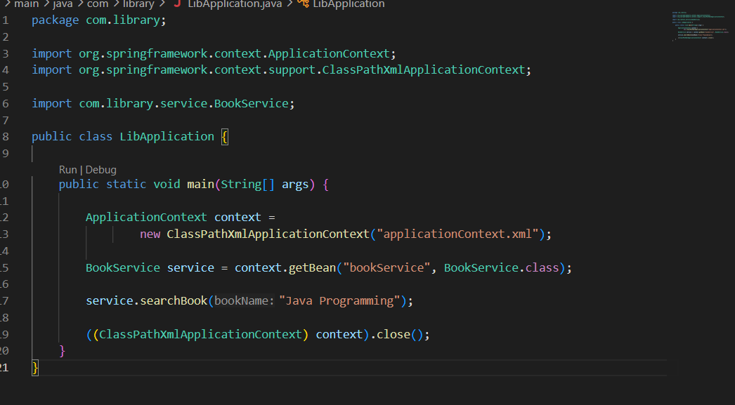
Output
